## Making prisms

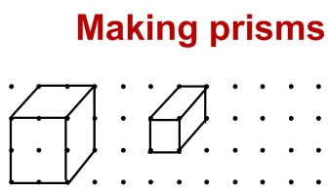With a partner, decide how you will draw your prisms. Take turns to draw a line between dots. The player who draws the line that completes a prism, writes their initial on that prism. The winner is the player with most prisms at the end of the game.

